Pena & Magnetic Brothers- the beginning

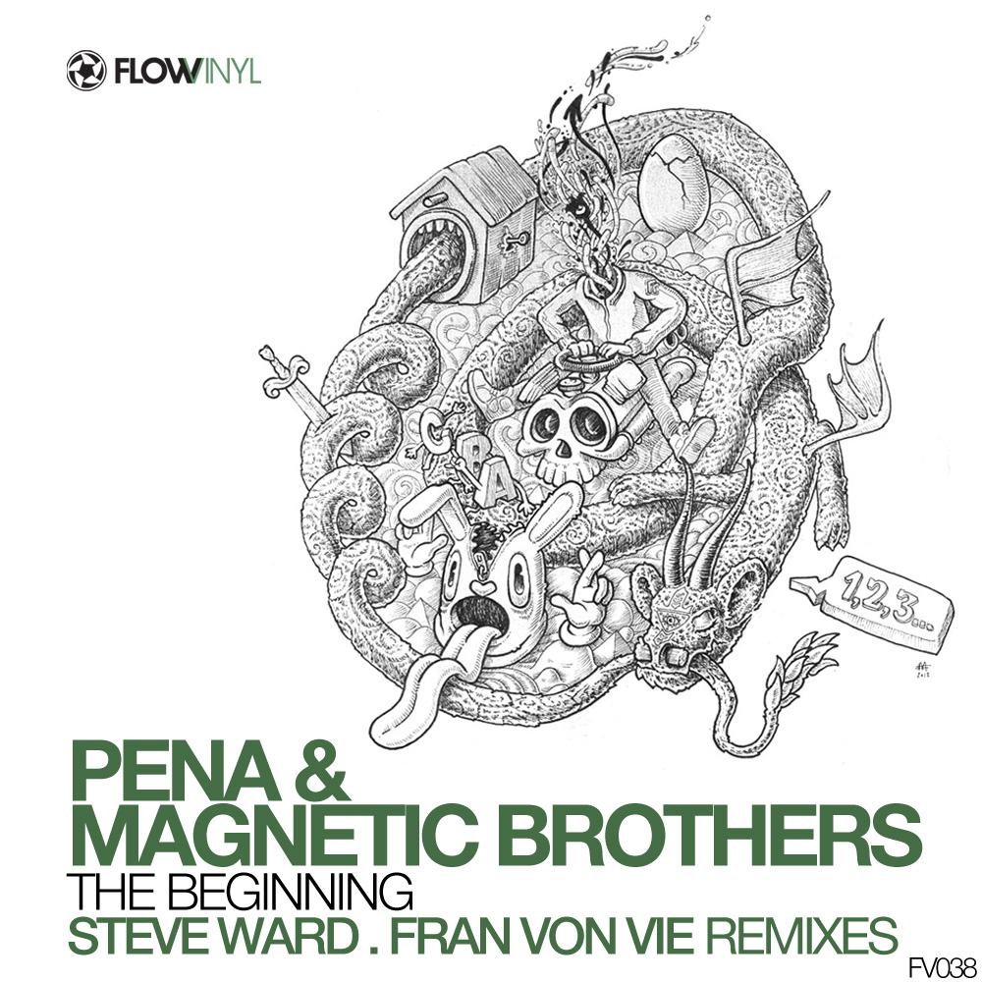 | Artist: Pena & Magnetic Brothers  Title: the beggining  Remixes: steve ward, fran von vie  Catalogue number: FV038  Release date: 21Feb 2012  Distribution: Ingrooves  Style: progressive house, tech house, techno  www.flowvinyl.com

TRACKLIST

Pena & magnetic Brothers- the beginning – original
Pena & magnetic Brothers- the beginning - steve ward remix
Pena & magnetic Brothers -the beginning - fran von vie remix

RELEASE DETAILS

Flow Vinyl proudly presents Pena´s own colaboration track with Magnetic Brothers from Russia.
The remixes come from the very cool aussie Chameleon records Steve Ward on an tech house tip and spanish Fran Von Vie with a more progressive techno and darkish main room deep vibe.
The next releases will feature some amazing art illustrations connected with each ep theme, from our portuguese master Mario Belem www.mariobelem.com

FEEDBACKS

Hernan Cattaneo
very very good . support
Cid Inc (Replug Records)
very good, all three gets my support
Stelios Vassiloudis (Bedrock)
Really like what Steve Ward does and this is no exception. Nice package overall
Randall Jones (AudioTherapy, Bedrock)
Nice mixes! Will play these in my sets 100%
James Monro (4D/Midnight Ramblers)
great release mate! Steve’s mix doing the do! Thnx
Wehbba (Tronic)
liking steve ward’s mix, nice tune
Guy J (Bedrock)
Original mix for me , thnx good luck
Quivver (Boz Boz)
3 great mixes. i think steve ward is the one i’ll be playing . thanks
Guy Mantzur (Definitive /Plattenbank/Flow)
wow mates ,this is really good ep , original & remixes , good luck !!
Sandra Collins (Perfecto/Frisky Deepsessions)
great release .. support, thanks : )
Monaque (serge) (Get Physical, microCastle)
Great release! Glad to see it all worked out ;)
Sarah Main (Pacha)
nice package..thanks guys
Chris Lake
d/l for lakey as i think he’ll like, i’ll update if he’s supporting, cheers, steve parry.
Federico Epis (GU, Flow)
Original + Fran’s remix are great !
Jemmy (Cream/Renaissance)
quality p.. nice artwork too
Pole Folder (Bedrock, Reworck)
Nice release. Thank you.
Alex & Filip (Mirabilis, Respekt, Rekluse)
wicked pack! will play all of em!
Fiord/Antix (Iboga, Flow)
Dig it.. Steves is a groover!
Darin Epsilon (Perspectives, Armada, microCastle )
Good pack but my favorite here is Steve Ward’s remix.
Kasey Taylor (Vapour Recordings/eVapour8)
Steve Wards is banging ;)
Kassey Voorn (Bedrock, Cocoon, Sudbeat)
great release, all 3 mixes are tops.
Sezer Uysal (Ministry Of Sound)
will play Steve Ward remix, thanks
Pablo Acenso (Flow, Balance, GU)
like all 3 mixes. thanks!
Uone (beef)
Steve Ward bring the good, quirky percussion, hypnotic and deep melody. Just the way i like! Thanks
Mitch Alexander (microCastle)
Magnetic Brothers are really under rated, i love those guys, great to see them on Flow. all the mixes are great but i like the Original the best.
Arjun Vagale / Jalebee (Excentric /Vapour/Flow )
Steve Ward remix is hot ! liking the original too
Deepfunk (SilenceThroughMusic, Bedrock,Flow)
Good stuff….. thanks :)
Tim Richards (flow, excentrik, iboga)
Steve Ward remix for me, great to see the old artwork back too!

