FLUTTER

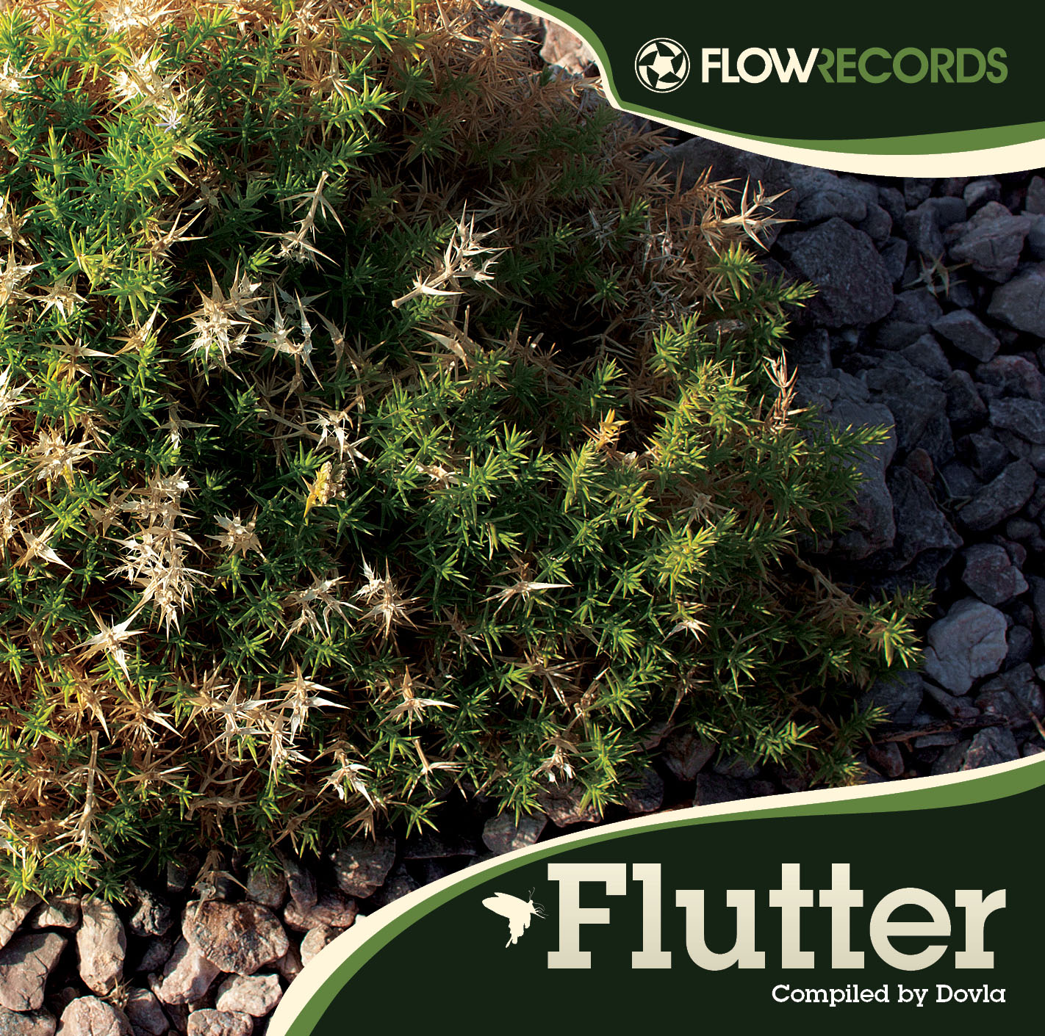
Artist: Various Artists
Title: Flutter
Format: CD (Jewel Case) & Digital
Catalogue number: FLR01026CD
Release date: December 2010
Distribution: Psyshop, Ingrooves
Style: freestyle, chillout, idm

www.flow-records.com
www.psyshop.com

TRACKLIST

01. Floex - Petr Parléř (5:46)
Written and produced by Tomáš Dvořák (Czech)
02. KiloWatts - Deliriously (5:19)
Written and produced by James Watts (USA)
03. Efterklang - Modern Drift (Rumpistol Remix) (6:10)
Remixed by Jens Berents Christiansen, Original written and produced by Mads Brauer, Casper Clausen, Rasmus Stolberg, Rune Mølgaard and Thomas Husmer (Denmark)
04. Dual Barrel - Spiffy Banter (6:30)
Written and produced by Igor Čeranić and Saša Dukić (Croatia)
05. Krusseldorf - Sparkling New (5:48)
Written and produced by Simon Heath (Sweden)
06. Red Seal - Revolver (4:08)
Written and produced by Charles McGougan (UK)
07. Casanueva - Halloween (7:14)
Written and produced by Simon Baring and Elio D’Anna (UK)
08. The Mollusk - Cameras (4:58)
Written and produced by Shane Vigo (Australia)
09. Simon Baring - Athens to Athens (6:43)
Written and produced by Simon Baring (UK)
10. Supercozi - August Human (Feat. Pheel) (6:43)
Written and produced by Cozi Till Yukimi Yonezawa (Japan)
11. Slackbaba - Go With The Flow (7:52)
Written and produced by Jonathan Smith (UK)
12. Noodle And Tweak - The Beat's Inside The Beat (4:21)
Written and produced by Chris Dinner and Steve Rowlands (UK)
RELEASE DETAILS

Flow records present Flutter! A fresh and entertaining journey brought to you by Interchill records’ DJ Dovla. Aside from his current post Dovla has now taken up the task of co-managing Flow from his Croatian base. Taking almost a full year to slowly hand pick some of the finest and most original music the scene has to offer. As well as gathering all the music Dovla has also created the cover artwork for the CD.

Being known for long and varied sets on the chill out floors made the task of putting all of these sounds into one CD a difficult one indeed, the end result, 12 amazing tracks with a mashed up freestyle sound that’s guaranteed to tickle your ear lobes. We start things off with some smooth ambiental bliss from Floex, known for his incredible soundtrack work on the Machinarium game, continued by equally smooth glitch goodness by Kilowatts. Rumpistol follows up with an incredible remix of Danish band Efterklang. Croatian newcomer duo Dual Barrel takes their rightful place here and keep the flow going along with Krusseldorf who takes the jazzy note. Red Seal is back, with a funky trip hop sound to take us further. Simon Baring and Casanueva present their own new and original brand of twisted disco while The Mollusk gives us a demo of how they smash the beats down under. Supercozi and Pheel bring an equally powerful mash of lounge mellow beats while Slackbaba maintains the pace with some breakbeat goodness. We pick up the pace in the end and let Noodle and Tweak (of Pushmipulyu fame) run wild with an uplifting funky and eclectic tune to end things off with a bang, filling up as much space as possible and making sure this one stays in your CD case for a long while.

Just enjoy, feedback us and remember that there´s plenty of hard work here, so please keep it for yourself

SUPPORT THE UNDERGROUND SCENE. NO PIRACY!

